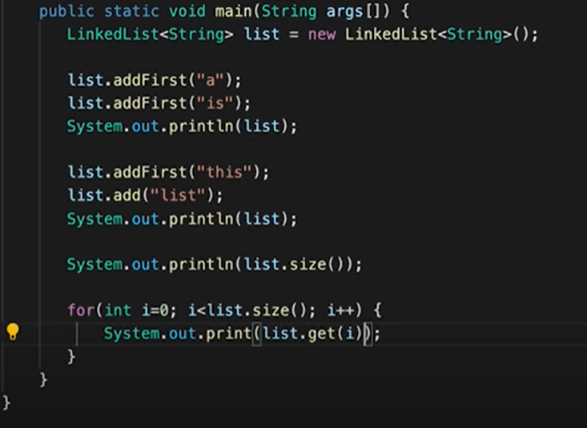

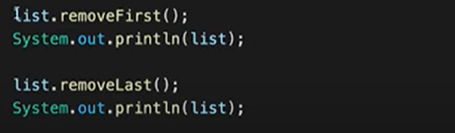

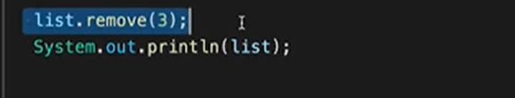

add(element): Adds the specified element to the end of the list.

add(index, element): Inserts the specified element at the specified position in the list.

remove(index): Removes the element at the specified position in the list.

get(index): Returns the element at the specified position in the list.

size(): Returns the number of elements in the list.

isEmpty(): Returns true if the list is empty, false otherwise.

clear(): Removes all elements from the list.

contains(element): Returns true if the list contains the specified element, false otherwise.

indexOf(element): Returns the index of the first occurrence of the specified element in the list, or -1 if not found.

lastIndexOf(element): Returns the index of the last occurrence of the specified element in the list, or -1 if not found.

set(index, element): Replaces the element at the specified position in the list with the specified element.

toArray(): Returns an array containing all elements in the list.

iterator(): Returns an iterator over the elements in the list.

REVERSE A LINKED LIST RECURSIVE WAY :{{{ FOR ITERATIIVE WAY TAKE 3 POINTER NODES EACH FOR PREV CURRENT AND NEXT AND FOR EACH ITERATION GO ON FIXING THE LINK}}}

RECURSIVE-->

